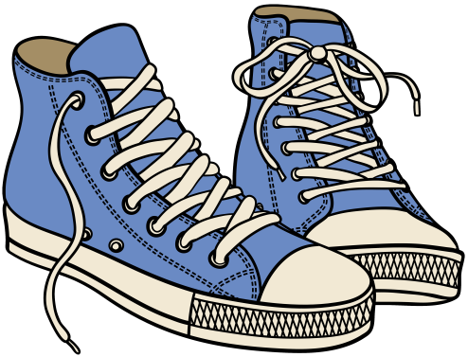
It’s Time to Kick-Off
Shoeman Water Project
Donation & Contest!

Fall 2016 Drive: [Monday, September 12]- Thursday, November 10
Spring 2017 Drive: [Monday, January 9]- Friday, April 7

What is Shoeman Water Project?

- Shoeman Water Projects picks up donated used and new shoes year-round from businesses, churches, and schools.

- Shoes are given a second life when the Shoeman exports the donated shoes to retailers in the developing world. The resale of shoes provides jobs and affordable footwear.

- Money earned from the export of shoes provides well drilling rigs, water purification systems, and hand pump repair to bring clean, fresh water to developing countries.

- Easy access to fresh water allows more children to attend school, rather than walking several miles each day to fetch drinking water for their families.

How Will [Name of Your School] Help?

- Starting [Month, Day of collection start date], bring in any type of shoes including athletic, running, dress, sandals, pumps, heels, work boots, cleats, dance, and flip flops. As long as they do not have holes in them, they are needed! (Please, no house slippers.)

- Shoes should be rubber-banded or tied together.

- At the end of the drive, shoes will be counted by [name of school’s] Green School Coordinator and collected by Shoeman.

- The top three schools that collect the most shoes per capita will be awarded a cash prize of $500, $300 or $200 by Madison County Green Schools Program!

- THIS YEAR: If 15,000 shoes are collected locally, Shoeman will name a well in Panama after Madison County!
For more information, visit http://www.shoemanwater.org
Questions? Contact [Building Coordinator Name]

