We’re Keeping Tabs on Recycling!
Dear Parents and Caregivers,

[Green Elementary] school is excited to tell you about our participation in a recycling
program, in conjunction with Madison County Green Schools Program and
Highland Recycling and Shredding.

Collection bins for metal tab tops from beverage cans will be placed all around [Green Elementary]. Throughout the school year/during collection time, students are encouraged to bring in tab tops as an indication that they are recycling cans at home, or where programs are available.

On April 8th of 2017, tab tops will be weighed by Highland Recycling and Shredding, and our school will receive a check for the metal we’ve collected. These funds may be used by our school or for a charity of our choosing. Please help support our efforts by sending your child with any tab tops you may have. Drop-off boxes will be located in classrooms and around the school for your child to deposit the tab tops.

Thank you in advance for participating! With the help of parents and caregivers like you, we raise awareness about recycling and responsible use of resources, while benefitting our school and community.
Additional questions may be directed to [Green Schools Building Coordinator email.]

Sincerely,
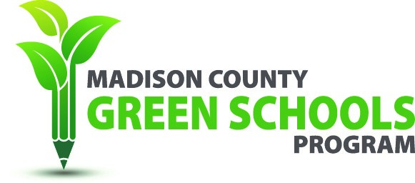

[Your name and signature]

We’re Keeping Tabs on Recycling!
Dear Parents and Caregivers,

[Green Elementary] school is excited to tell you about our participation in a recycling
program, in conjunction with Madison County Green Schools Program and
Highland Recycling and Shredding.

Collection bins for metal tab tops from beverage cans will be placed all around [Green Elementary]. Throughout the school year/during collection time, students are encouraged to bring in tab tops as an indication that they are recycling cans at home, or where programs are available.

On April 8th of 2017, tab tops will be weighed by Highland Recycling and Shredding, and our school will receive a check for the metal we’ve collected. These funds may be used by our school or for a charity of our choosing. Please help support our efforts by sending your child with any tab tops you may have. Drop-off boxes will be located in classrooms and around the school for your child to deposit the tab tops.

Thank you in advance for participating! With the help of parents and caregivers like you, we raise awareness about recycling and responsible use of resources, while benefitting our school and community.
Additional questions may be directed to [Green Schools Building Coordinator email.]

Sincerely,

[Your name and signature]

