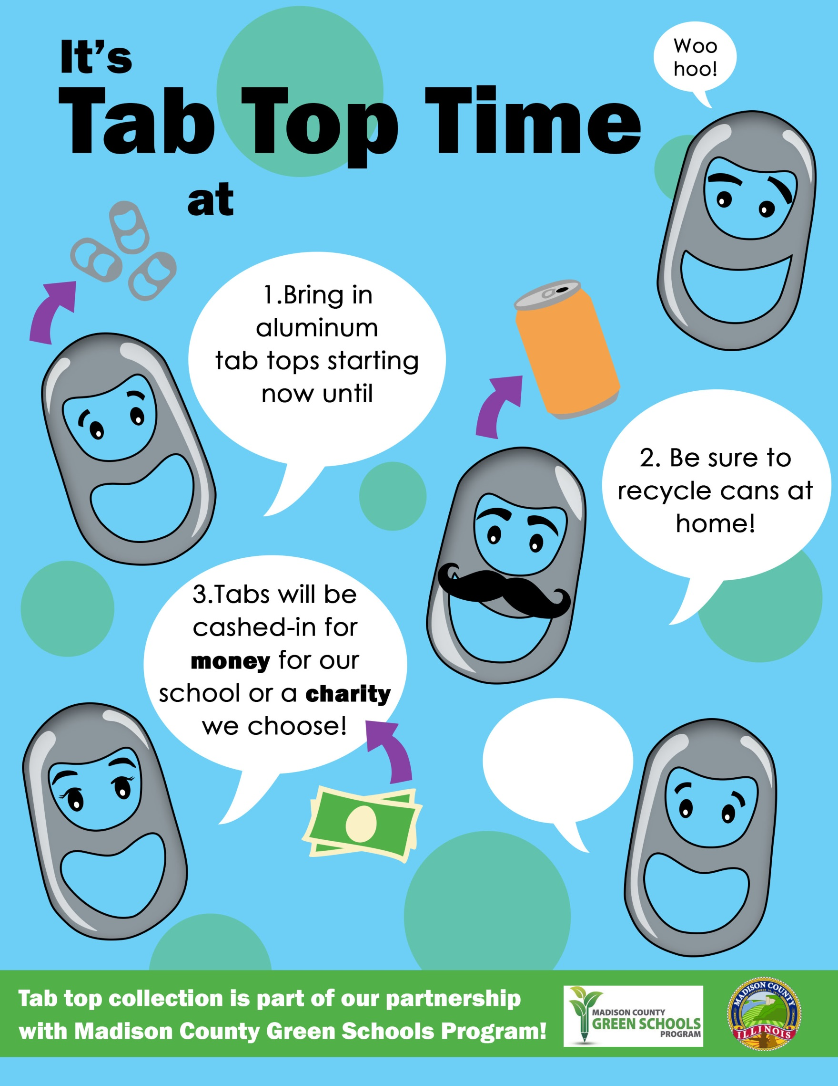

April 7th!

**4.See Mrs. Green for more!**

Madison School!