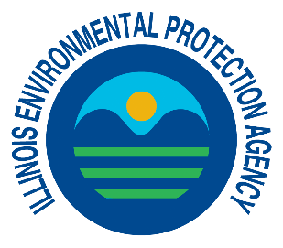 | 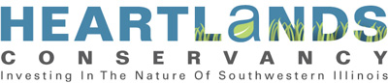 | 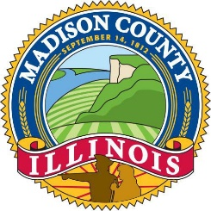

CONTACT:
Kim Biggs, Illinois EPA
Kim.Biggs@illinois.gov
(217) 558-1536 or
Tyler Burk, HeartLands Conservancy
tyler.burk@heartlandsconservancy.org
(618) 566-4451 ext. 25

Feb. 4, 2020
FOR IMMEDIATE RELEASE

Illinois EPA awards nearly $954,000 to HeartLands Conservancy for water quality protection within the Canteen Creek-Cahokia Creek Watershed

SPRINGFIELD — Illinois Environmental Protection Agency Director John J. Kim announced HeartLands Conservancy will receive nearly $954,000 in grant funding to provide technical and financial assistance to rural and urban landowners to voluntarily implement the locally developed Canteen Creek-Cahokia Creek Watershed Plan.

“This project will help landowners implement best management practices in the Canteen Creek-Cahokia Creek Watershed to reduce nonpoint source pollution, soil erosion and nutrient and sediment loading, in order to improve overall water quality,” Director Kim said. “This watershed is identified by Illinois EPA as a priority watershed for nonpoint source implementation activities this year.”

HeartLands Conservancy, an environmental non-profit serving southwestern Illinois, applied for the Section 319(h) grant in partnership with Madison County and Madison County Soil and Water Conservation District (SWCD). The total project cost is around $1.65 million, with Illinois EPA providing 58 percent or $953,869 in grant funds and local landowners and partners (HeartLands Conservancy, Madison County and Madison County SWCD) providing 42 percent, or $697,126 in match.

Madison County will put $40,000 toward the project. The County’s Planning and Development Committees will vote on a resolution on Thursday, February 6, to allocate the funding before forwarding it to the County Board at its meeting on February 19.

Tyler Burk, project manager with HeartLands Conservancy, said that participation from local landowners, farmers, residents and municipalities is crucial to the success of implementation of the locally developed Canteen Creek-Cahokia Creek Watershed Plan (December 2018).

“Development of the Canteen Creek-Cahokia Creek Watershed Plan allowed local stakeholders to identify local water quality and flooding issues, thanks to Madison County’s Stormwater Master Planning process,” Burk said. “All of our partners in the watershed are excited for the opportunity to implement best management practices that will help solve those issues.”

The grant is a first step towards the voluntary implementation of the Canteen Creek-Cahokia Creek Watershed Plan, which addresses stormwater and nonpoint source (NPS) pollution issues in the watershed that drains Canteen and Cahokia creeks in Madison and St. Clair counties. NPS pollution occurs when runoff from rain and snowmelt carries pollutants into waterways such as rivers, streams, lakes, wetlands and even groundwater.

The Section 319(h) Grant Program is a competitive financial assistance grant program established to help control NPS pollution. Federal funds are designated to the Illinois EPA under Section 319 of the Clean Water Act. The funds are then used to support state NPS management programs.

The Canteen Creek-Cahokia Creek watershed includes all or parts of the following municipalities: Caseyville, Collinsville, Edwardsville, Fairview Heights, Glen Carbon, Maryville, Pontoon Beach and Troy.

The project will assist local landowners to voluntarily implement best management practices (BMPs) in the Canteen Creek-Cahokia Creek watershed to reduce nonpoint source pollution, soil erosion, and nutrient and sediment loadings in order to improve water quality.

The BMPs eligible for cost-share include:
- grassed waterways
- ponds, water and sediment control basins
- wetland restoration
- shoreline stabilization
- stream channel restoration
- stream channel stabilization
- streambank stabilization
- bioswales
- porous pavement
- rain gardens
- urban filter strips
- tree planting

The local watershed management plan compliments the Madison County Stormwater Management Plan, the overall framework for stormwater management in the county, which guides regulations, identifies flood and water quality problems, establishes best management practices and prioritizes work to be done. Contact Tyler Burk at the HeartLands Conservancy to learn more or to sign-up for the cost-share program.

For additional information on Illinois’ Nonpoint Source Management Program and the 319(h) Grant Program, please visit https://www2.illinois.gov/epa/topics/water-quality/watershed-management/nonpoint-sources/Pages/default.aspx.

For information and updates on this project visit www.HeartLandsConservancy.org or follow their Facebook page @HeartLandsConservancy.

###

